Name:Shreya Kumari

Roll_no:-13221

import matplotlib.pyplot as plt

from collections import deque

# Generate a random graph

def generate_graph(num_nodes, probability):

G = nx.erdos_renyi_graph(num_nodes, probability)

return G

# BFS (Breadth-First Search)

def bfs(graph, start_node):

visited = set()

queue = deque([start_node])

result = []

while queue:

node = queue.popleft()

if node not in visited:

visited.add(node)

result.append(node)

queue.extend(neighbor for neighbor in graph.neighbors(node) if neighbor not in visited)

return result

# DFS (Depth-First Search)

def dfs(graph, start_node):

visited = set()

result = []

def dfs_helper(node):

visited.add(node)

result.append(node)

for neighbor in graph.neighbors(node):

if neighbor not in visited:

dfs_helper(neighbor)

dfs_helper(start_node)

return result

# Plotting the graph

def plot_graph(graph):

pos = nx.spring_layout(graph)

plt.figure(figsize=(8, 6))

nx.draw(graph, pos, with_labels=True, node_size=500, node_color='lightblue', font_size=12, font_weight='bold')

plt.title("Generated Graph")

plt.show()

# Main menu loop

def main():

graph = None

while True:

print("\nMenu:")

print("1. Generate a new random graph")

print("2. Perform BFS traversal")

print("3. Perform DFS traversal")

print("4. Show graph visualization")

print("5. Exit")

choice = input("Enter your choice (1-5): ").strip()

if choice == '1':

try:

num_nodes = int(input("Enter number of nodes: "))

probability = float(input("Enter probability of edge creation (0 to 1): "))

if not (0 <= probability <= 1):

print("Probability should be between 0 and 1.")

continue

graph = generate_graph(num_nodes, probability)

print("Graph generated successfully!")

except ValueError:

print("Invalid input, please enter valid numbers.")

elif choice == '2':

if graph is None:

print("Please generate a graph first.")

continue

start_node = int(input("Enter the starting node for BFS: "))

if start_node >= len(graph.nodes()):

print("Invalid start node!")

continue

print("BFS Traversal: ", bfs(graph, start_node))

elif choice == '3':

if graph is None:

print("Please generate a graph first.")

continue

start_node = int(input("Enter the starting node for DFS: "))

if start_node >= len(graph.nodes()):

print("Invalid start node!")

continue

print("DFS Traversal: ", dfs(graph, start_node))

elif choice == '4':

if graph is None:

print("Please generate a graph first.")

continue

plot_graph(graph)

elif choice == '5':

print("Exiting the program.")

break

else:

print("Invalid choice, please select a number between 1 and 5.")

# Run the main menu loop

if __name__ == "__main__":

main()

Test case 1:-

Menu:

1. Generate a new random graph

2. Perform BFS traversal

3. Perform DFS traversal

4. Show graph visualization

5. Exit

Enter your choice (1-5): 1

Enter number of nodes: 5

Enter probability of edge creation (0 to 1): 0.5

Graph generated successfully!

Menu:

1. Generate a new random graph

2. Perform BFS traversal

3. Perform DFS traversal

4. Show graph visualization

5. Exit

Enter your choice (1-5): 2

Enter the starting node for BFS: 0

BFS Traversal: [0, 1, 2, 3, 4]

Menu:

1. Generate a new random graph

2. Perform BFS traversal

3. Perform DFS traversal

4. Show graph visualization

5. Exit

Enter your choice (1-5): 3

Enter the starting node for DFS: 0

DFS Traversal: [0, 1, 2, 3, 4]

Menu:

1. Generate a new random graph

2. Perform BFS traversal

3. Perform DFS traversal

4. Show graph visualization

5. Exit

Enter your choice (1-5): 4

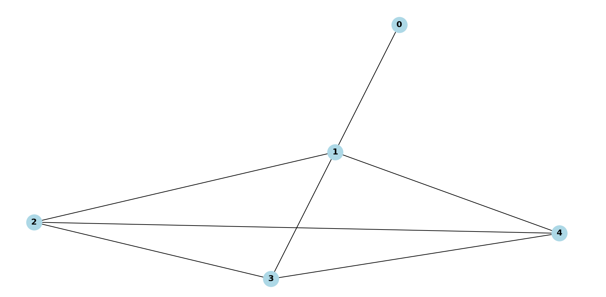

Test case 2:-

Menu:

1. Generate a new random graph

2. Perform BFS traversal

3. Perform DFS traversal

4. Show graph visualization

5. Exit

Enter your choice (1-5): 1

Enter number of nodes: 6

Enter probability of edge creation (0 to 1): 0.5

Graph generated successfully!

Menu:

1. Generate a new random graph

2. Perform BFS traversal

3. Perform DFS traversal

4. Show graph visualization

5. Exit

Enter your choice (1-5): 2

Enter the starting node for BFS: 0

BFS Traversal: [0, 2, 3, 4, 5, 1]

Menu:

1. Generate a new random graph

2. Perform BFS traversal

3. Perform DFS traversal

4. Show graph visualization

5. Exit

Enter your choice (1-5): 3

Enter the starting node for DFS: 0

DFS Traversal: [0, 2, 1, 4, 5, 3]

Menu:

1. Generate a new random graph

2. Perform BFS traversal

3. Perform DFS traversal

4. Show graph visualization

5. Exit

Enter your choice (1-5): 4

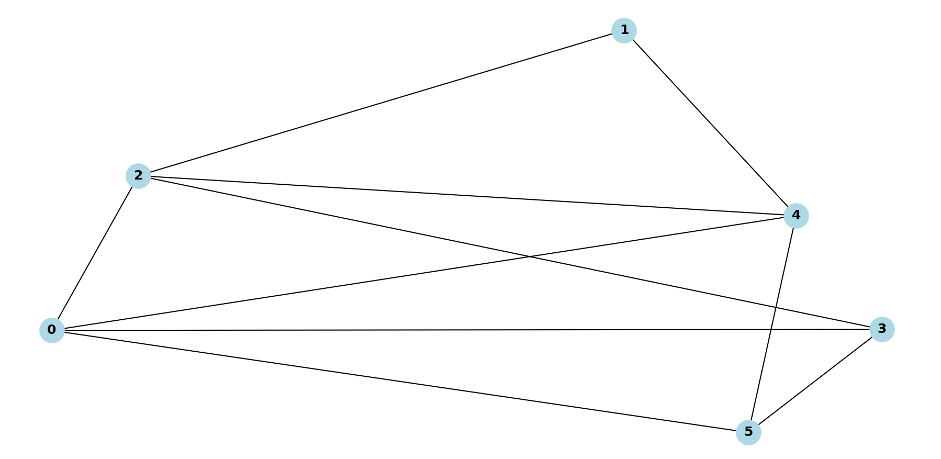

Menu:

1. Generate a new random graph

2. Perform BFS traversal

3. Perform DFS traversal

4. Show graph visualization

5. Exit

Enter your choice (1-5): 5

Exiting the program.